**ScreenShot 1**

Option for entering MRN Number and search.

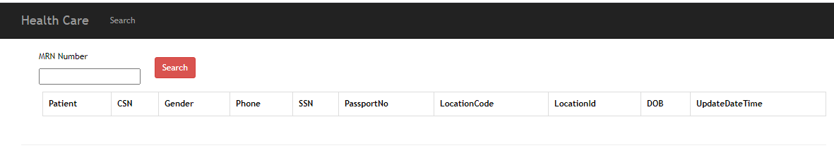

**Screenshot 2**

Showing result with success

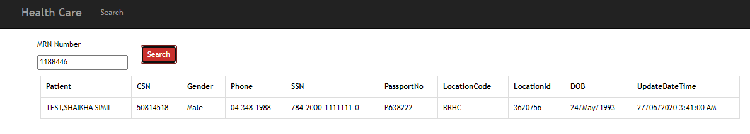

**Screenshot 3**

Validation fires when MRN is empty

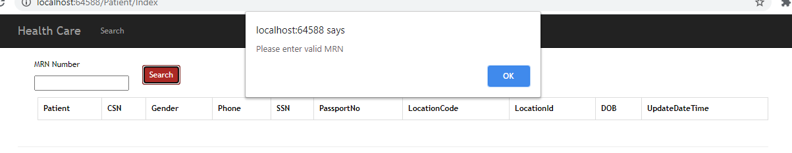**Projects**

**HealthCareEnquiry**

Web application used for view patient by entering MRN Number

Technology Stack : Asp.net MVC/C#/Sql Server/JQuery/Ajax/Bootstrap/EntityFramework

**HealthCareService**

**Windows service for reading text files in specified interval . Interval and folder path configured in App.config**

Technology Stack : C#/Serilog package for logging day wise information.